OT-One: Connecting Motors

Learn how to connect the X, Y, and Z-axis motors on your robot



Written by Opentrons

Updated this week

# This article is about the OT-One.

## **It's no-longer sold or actively supported by Opentrons, but we've kept this article here to help existing users. Please** [**see our OT-2 Support articles**](https://support.opentrons.com/) **for the most up to date information!**

## **Overview:**

Your robot was shipped with the motors disconnected to prevent voltage buildup during transport. After you remove the locking bolts, quickly snap the connectors into place for each of the motors. Use the photos below for guidance:

Y-Axis Motors:

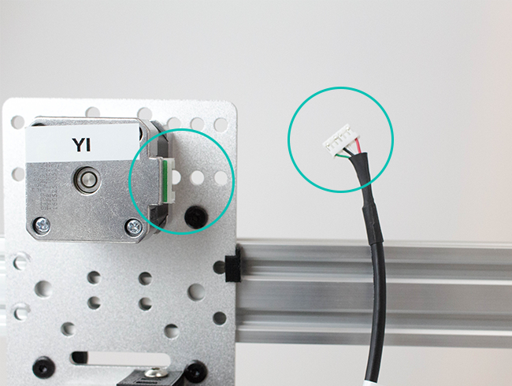

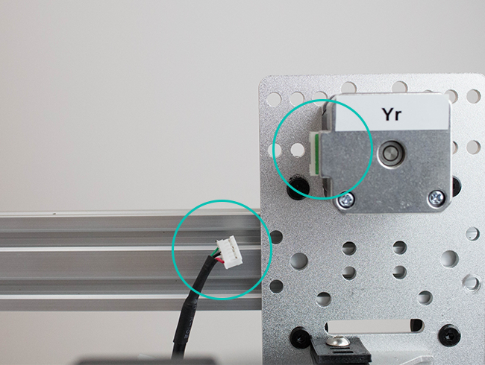

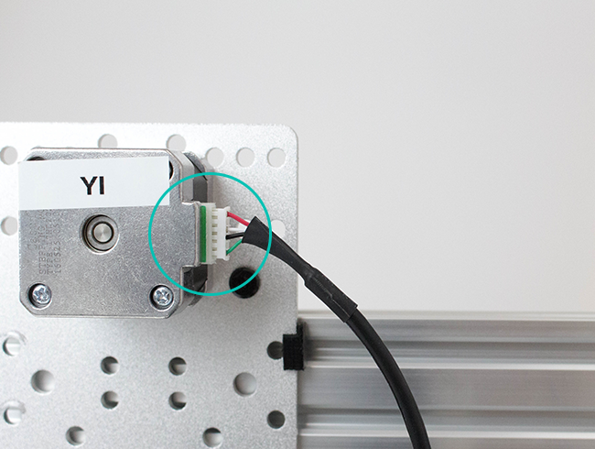

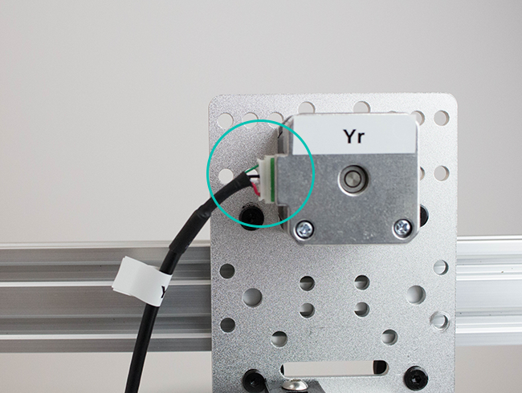

X-Axis Motor:

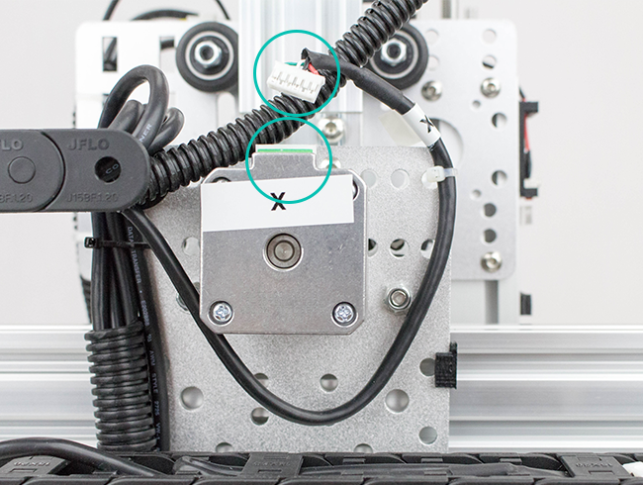

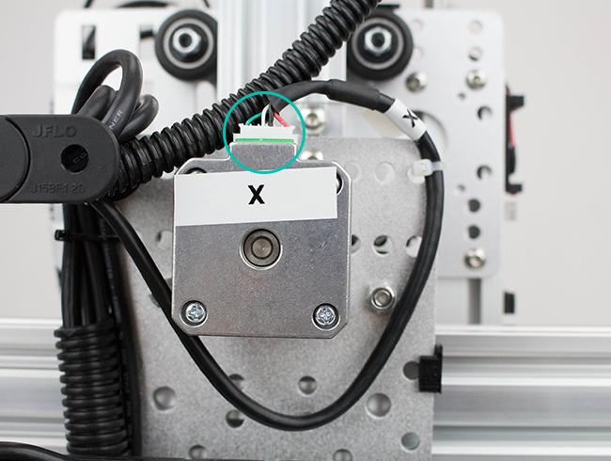

Z-Axis Motor:

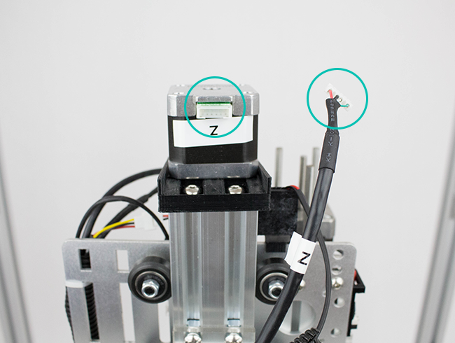

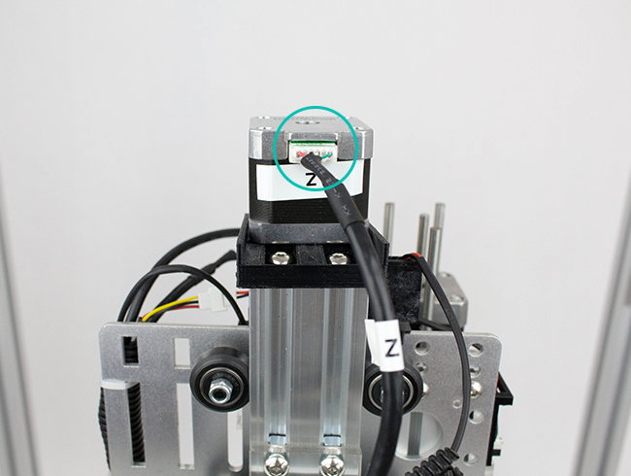

X and Z-Axis Motors connected:

